**Capabilities Document**

**Project:** ECSE211 Design Project – Capture the Flag

**Task:** Construct an autonomous robot that can play one-on-one version of the game Capture the Flag

**Document Version Number:** Version 1.2

**Date:** November 27, 2017

**Authors:** Priscilla Ip

**Edit History:**

- Created: 15/10/2017

|  |  |  |  |
| --- | --- | --- | --- |
| **Date** | **Edited By:** | **Section** | **Reason** |
| Oct. 15, 2017 | Priscilla | All | Compiled and formatted information discussed as a team |
| Oct. 29, 2017 | Younes | Availability | Added a deadline |
| Nov. 27, 2017 | Priscilla | Table of Contents | Added links |

1. **Table Of Contents**

2.0 Team Members………………………………………………………………………………...2

3.0 Capabilities……………………………………………………………………………………..2

4.0 Possible Application Areas………………………………………………………………….. 3

5.0 Availability……………………………………………………………………………………... 4

6.0 Glossary of Terms……………………………………………………………………………. 5

1. **Team Members**

|  |  |  |  |
| --- | --- | --- | --- |
| **Name** | **Phone** | **Gmail** | **McGill Email** |
| Paarth Kalia | 506-721-9013 | paarthkalia@gmail.com | paarth.kalia@mail.mcgill.ca |
| Priscilla Ip | 514-758-1141 | ip.pippy@gmail.com | priscilla.ip@mail.mcgill.ca |
| Younes Boubekeur | 514-462-3231 | youyou.van@gmail.com | younes.boubekeur@mail.mcgill.ca |
| Ismail Faruk | 438-926-9277 | ismailfaruk.17@gmail.com | ismail.faruk@mail.mcgill.ca |
| Chaoyi Liu | 514-625-3318 | chaoyi97@gmail.com | chaoyi.liu@mail.mcgill.ca |
| Mahad Khan | 438-928-3497 | mahadhasankhan@gmail.com | mahad.khan@mail.mcgill.ca |

1. **Capabilities**

|  |  |  |  |
| --- | --- | --- | --- |
| **Name** | **Software Capabilities** | **Electrical/ Mechanical Skills** | **Management Skills** |
| Paarth Kalia | Inexperienced | Average | Experienced |
| Priscilla Ip | Inexperienced | Experienced | Experienced |
| Younes Boubekeur | Experienced | Inexperienced | Experienced |
| Ismail Faruk | Inexperienced | Experienced | Average |
| Chaoyi Liu | Experienced | Inexperienced | Average |
| Mahad Khan | Average | Average | Average |

*skill level is relative to other team members

**Paarth** majors in Computer Engineering. He has taken up to COMP 250 and has basic circuits/digital logic knowledge. In addition, he has mentoring and leadership experience from various teaching roles and event organization as well as experience with agile programming setup and sprint-type modular work

**Priscilla** is an Electrical Engineering major. She has taken up to COMP 250 and has knowledge of circuits and control systems. She also has leadership experience from being an executive on student councils. Last summer, she had a Retail Marketing Internship and she is comfortable with writing and working with documents.

**Younes** majors in Software Engineering. He enjoys working with the hardware and has taken several courses beyond COMP 250 related to software namely COMP 251 and ECSE 321. In previous group projects, he has taken a leadership role and is a part of the International Student Buddies program.

**Ismail** is an Electrical Engineering major. He is currently taking COMP 250 and has knowledge of circuits/control systems. In addition, he discovered a fondness working with the hardware during the research and development labs.

**Chaoyi** majors in Software Engineering. She has basic electrical skills from circuits courses and experience from several software courses beyond COMP 250 such as COMP 251 and ECSE 321.

**Mahad**is a Computer Engineering student. He has some experience in software beyond COMP 250 and knowledge of circuits, digital logic and basic mechanical concepts.

1. **Possible Application Areas**

|  |  |
| --- | --- |
| **Task** | **Team Member** |
| Management | *Paarth, Priscilla, Younes* |
| Documentation | *Priscilla* – General formatting, proofreading, compiling, meeting presentations, test documents  *Paarth* – Gantt Chart, PERT Chart, Hardware documents  *Younes, Mahad* – Software documents |
| Mechanical Design | *Ismail* – Mainly responsible; Design and sketch hardware implementations  *Paarth, Mahad* – Provide support and second opinions, help implement |
| Software Design | *Younes, Chaoyi* – Software hierarchy, overall design |
| Test Design | *Chaoyi –* Mainly responsible; Set standards, design tests  *Priscilla, Ismail* – Provide support and second opinions |
| Software Development | *Younes, Chaoyi, Mahad –* Document and develop software |
| Research and Development | *Chaoyi –* testing, calibrating and selecting sensors |
| Integration Testing | *Chaoyi* – Design tests  *Chaoyi, Priscilla, Ismail* – Carry-out testing  *Younes, Paarth –* On stand-by for debugging and consultation |

1. **Availability**

**Reoccurring Events**

* *Wednesdays 6-8 –* McGill Club meetings (Priscilla)
* *Saturday Afternoons* (no set time) – Driving Lessons (Younes)

**Unique Events**

|  |  |
| --- | --- |
| **Week** | **Events** |
| Week 1:  Oct 16 – Oct 20 | * October 19 – ECSE 331 Quiz (Paarth, Priscilla) * October 20 – FACC 400 Debate (Younes) |
| Week 2:  Oct 23 – Oct 27 | * October 25 – ECSE 324 Midterm (Paarth, Priscilla, Younes, Chaoyi) |
| Week 3:  Oct 30 – Nov 3 | * October 31 – ECSE 331 Midterm (Paarth, Priscilla, Ismail) * November 2 – ECSE 331 Quiz (Paarth, Priscilla) * November 3 – ECSE 307 Midterm (Priscilla, Ismail) |
| Week 4:  Nov 6 – Nov 10 | * November 6 – ECSE 321 Midterm (Ismail) |
| Week 5:  Nov 13 – Nov 17 | * November 11 – ECSE 429 (Younes) * November 13 – ECSE 353 Midterm (Paarth) * November 16 – ECSE 331 Quiz (Paarth, Priscilla) * **November 16 –** Beta Demo |
| Week 6:  Nov 20 – Nov 24 | * None |

**Weekly Availability**

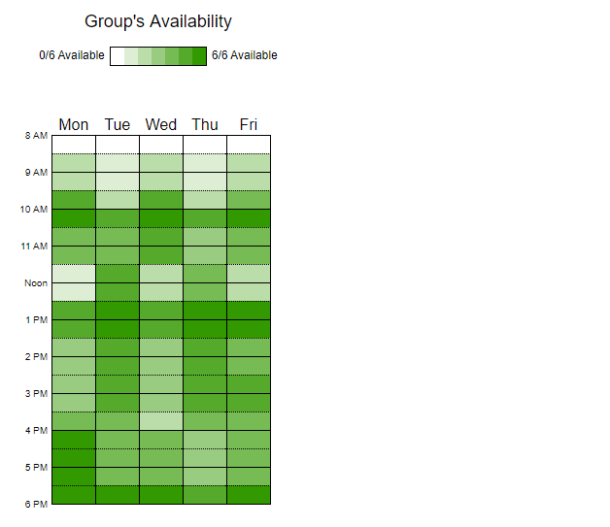

1. **Glossary of Terms**

* Beta Demo*:* display of the capabilities of the product to-date (See the [*Beta Demo Review Document*](Beta%20Demo%20Review%20Document.docx) for full details)
* Integration Testing*:* testing of the various software systems with regards to the purpose of the product